Trello: <https://trello.com/b/c80v5WmR/impress-express>

Site:

Prototipagem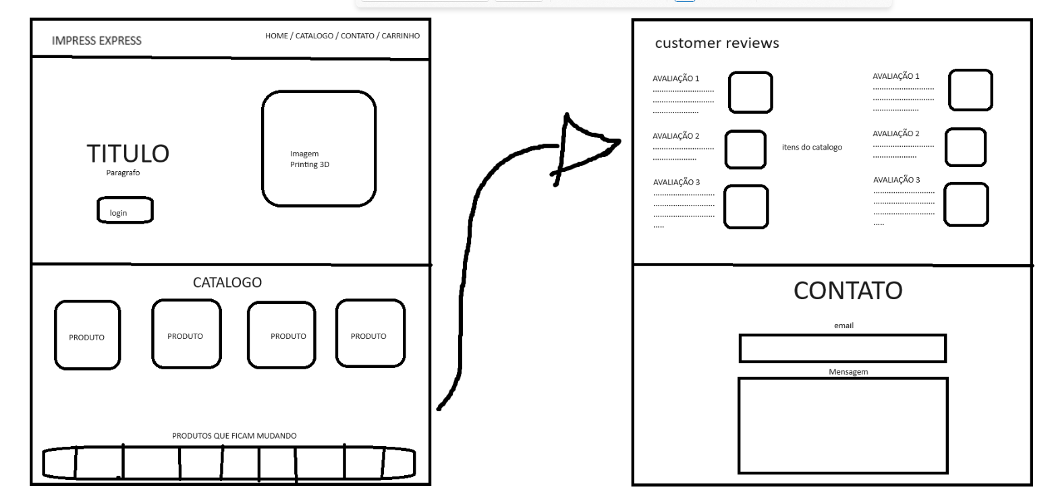

Notion/Metas: <https://www.notion.so/Impress-Express-8afb3e84a26b4d67b0d7ecea69f8b219?pvs=4>

Roadmap: <https://www.canva.com/design/DAGC0WCfiIM/t3UX0feftDShjJ1sGr8QHA/edit?utm_content=DAGC0WCfiIM&utm_campaign=designshare&utm_medium=link2&utm_source=sharebutton>

Pitch Deck: <https://www.canva.com/design/DAGC0NbaaJ0/RZR-q-G1HvLjcB9yzzo58w/edit?utm_content=DAGC0NbaaJ0&utm_campaign=designshare&utm_medium=link2&utm_source=sharebutton>